S P R I N G GOOD NEWSLETTER 2020
LOCUST GROVE CHURCH, Pastor Joe Briseno
www.locustgrovechurch.org 217-768-3384 or 217-825-9783

GREETINGS FROM LGC Hope you’ll take a minute to see what’s been going on and how much we’d like you to be a part of it all! In fact, our biggest announcement is that 2020 marks our 165th anniversary! That is a testimony to God’s faithfulness and those who have ever supported this ministry. Can’t wait to meet you in person! LGC is the place to be! We simply love being part of this family

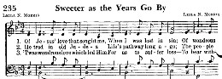
but there is always room for more. So if we are out in the middle of nowhere, how can we build the kingdom? By going outside our four walls, that’s how. It is a pleasure to share Pastor Joe’s sermons on our website, radio, and social media. Volunteers write and voice-over commercials of hope every Fri-Sun. A short takeaway from midweek service is tweeted for another audience. Good news is meant to be shared!

CAN I GET A WITNESS? Last fall we made our second music video to this contemporary song, which is also a frequent question asked by Pastor Joe! Fountains and mountains, taking oaths and tossing greenbacks, flying W’s and flossing moves, high kicks and Hallelujahs!

His love is like a fountain, it will never run dry!

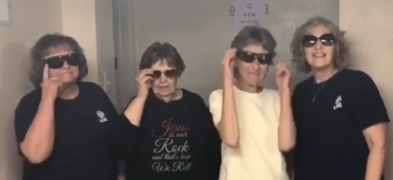

YOUTH LOCK-IN The new year began with 27 teens and brave adults locked in all night long. Pizza, crafts, worship, PJ, and lived to tell about it! Let’s do it again!

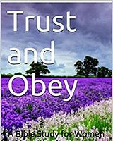

ALL IN THE FAMILY Lyle & Jean Jordan celebrated 68 yrs of marriage, Kaley & Austin were married in Sept, and Gretchen & Curt are planning a July wedding! We are encouraged to see new faces and hear children’s voices each Sunday! Can’t wait till VBS June 22-26 and Camp Maranatha for all ages! Call for dates!

GETTING BACK TO OUR ROOTS Traditions are hard to break so why try? On March 1 we had our annual

oyster supper on a 60-degree day! Thanks to the cooks and many visitors who go the distance to make it happen. It’s also hard to say goodbye to an OLD friend—a massive maple behind the church leaning the wrong way. Last fall it was professionally taken down limb by limb and many kept slices of the trunk for a keepsake.

A.L.I.C.E. TRAINING Last September many of us took part in a safety class put on by two Shelby Co deputies. Our eyes were opened to being prepared for the unexpected in many different situations no matter where we are. Our trustees made some recommended improvements to make LGC a safe place to worship.

Locust Grove will be the host for Good Friday services Friday, April 10 @ 6:30pm. On Easter morning April 12 @ 10am hear our choir’s special music mixed in with Pastor Joe’s message of hope!

SINGING MEN OF SAVOY Plans are in progress to co-sponsor this group from all walks of life bringing a variety of familiar vocal and instrumental music ranging from hymns, modern praise, patriotic, and even show tunes. Their magnetic appeal to the audience will make this a memorable event this fall! WATCH FOR DETAILS!!!

