S P R I N G GOOD NEWSLETTER 2019
LOCUST GROVE CHURCH, Pastor Joe Briseno
www.locustgrovechurch.org 217-768-3384 or 217-825-9783

OUR SPRING ISSUE is looking at our past, present, and future! We were so thankful for the wide variety of speakers over the last few months that kept us growing, even stretching our wings in new directions of ministry like never before. God was in control as always!
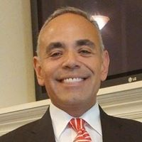
PASTOR JOE BRISENO And so now we’d like to introduce our new pastor, Joe Briseno! Pastor Joe is originally from El Paso, TX and attended seminary at Oral Roberts University. He has been in full-time ministry for 27 years, and most recently as a hospice chaplain in central IL. In a very short time we have seen for ourselves his passion for teaching the Word of God and healing broken people. Joe is the father of three daughters, granddad to three, a marathon runner, and sports enthusiast. Fiancée Kelly, is looking forward to being part of our church family in time as well. He looks forward to making new friends in the surrounding communities as well as following area school events. Pastor Joe has already breathed fresh life into our church with his teaching style and loving ways! We can’t wait for you to meet him!

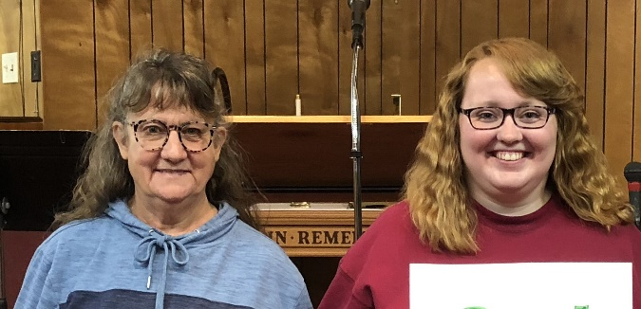
NEW MEMBERS soul sisters

There’s always plenty of room in the family of God. Last November it brought us great joy to welcome Mary Jo Allen and Kayla Gibson as new members. These two have been such an encouragement to us at this time as they bring so much joy and willingness to serve. Everyone needs a place to belong! Church is a great place to start!

HOLY WEEK Believing Christ died is history. Believing He died for you is salvation! If you only had one son, would you send him to the cross like God did? Love led Jesus to Calvary, but He’s living today! Celebrate with us on Easter morning!

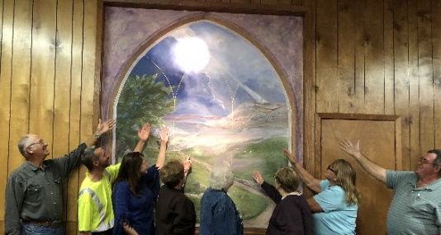

GRACE GOT YOU Lights-Camera-Action!

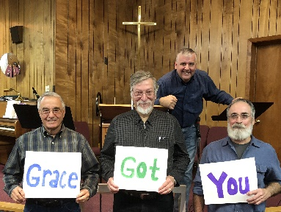
You’ve probably seen a few of the online video lip-sync challenges? Well, last fall some ladies got this crazy idea of producing an all-church video to a popular praise song to see if it caught on! It was more of a challenge for us to get everyone on board not to mention the know-how to actually get it done and done well! The night of “filming”, it became clear we were having so much fun and it would not be our last! Mustaches, popcorn, bubbles, lollipops, stadium wave, gliders, strobe light…just wow! Stay tuned and you can be part of the next one soon to be announced! Thanks to Kayla & Sheila, and thank God for grace!

Saturday, April 27 from 2-4:00

Lions Club

Moweaqua
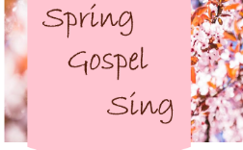

Friday, May 17

Potluck @ 6, Music @ 7

Open mic, share your gift
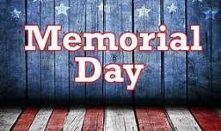

May 27 Community Service

Central Park, Moweaqua

Pastor Joe will be speaking

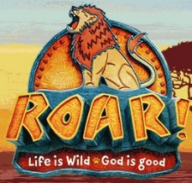
July 22-26 Roar VBS

6:30-8:30pm

Life is wild, God is good!

Join the herd at the mane event!

